2D game via Playground

Creating A New Project
- Let’s begin by opening up the latest version of Unity Hub, which can be downloaded from here: https://unity3d.com/get-unity/download
- Select the Projects tab and click on ‘New’.
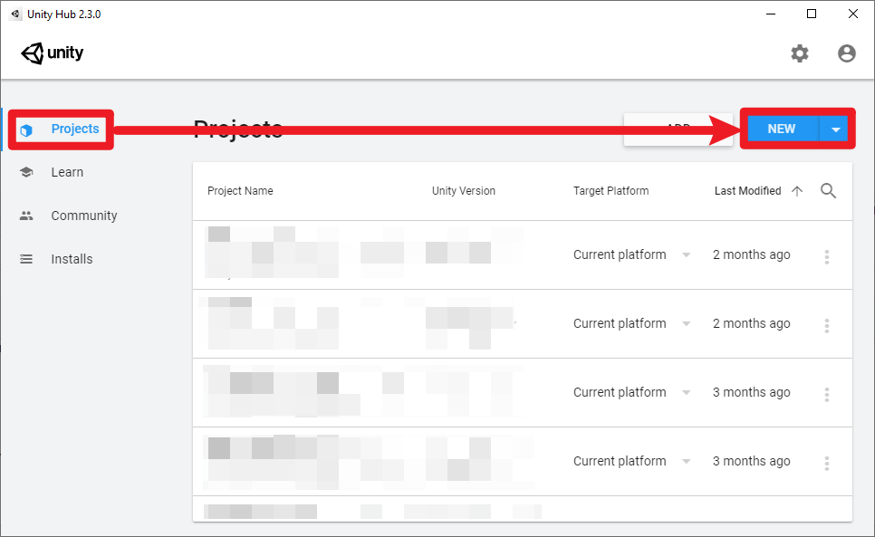
- Select 2D for the template and click on ‘Create’.
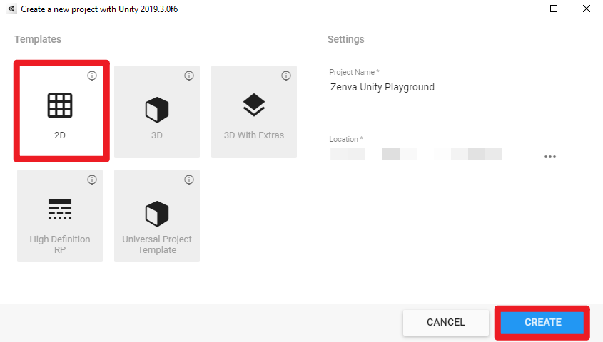
- This will open up the Unity Editor.
- Installing Unity Playground
- To download Unity Playground, go to Window > Asset Store.
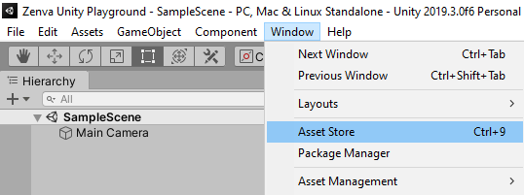
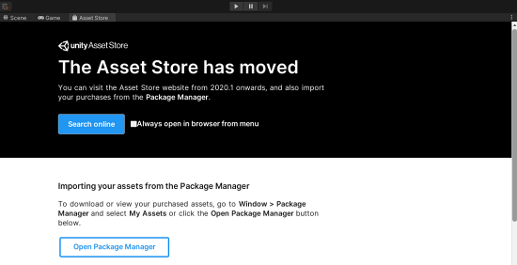
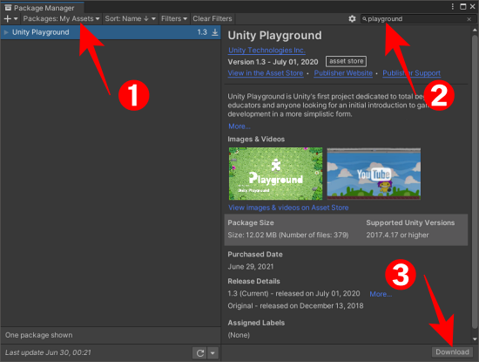
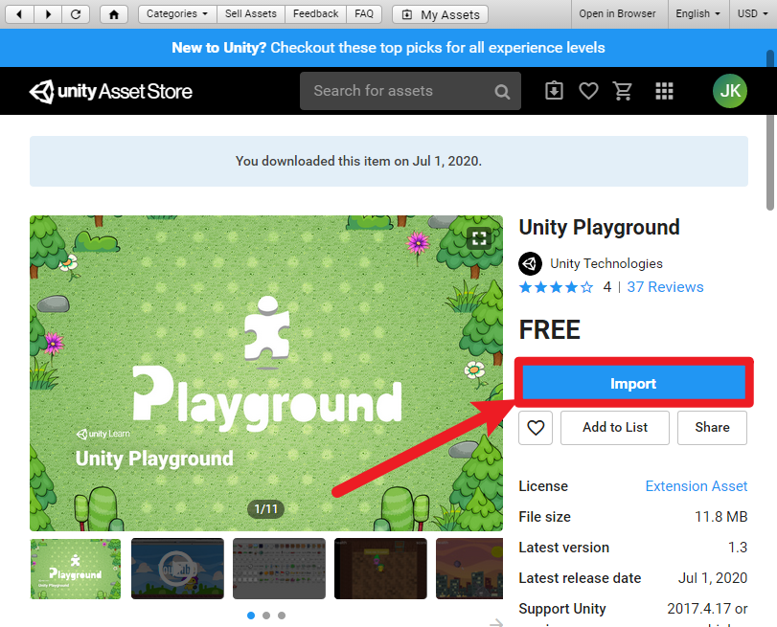
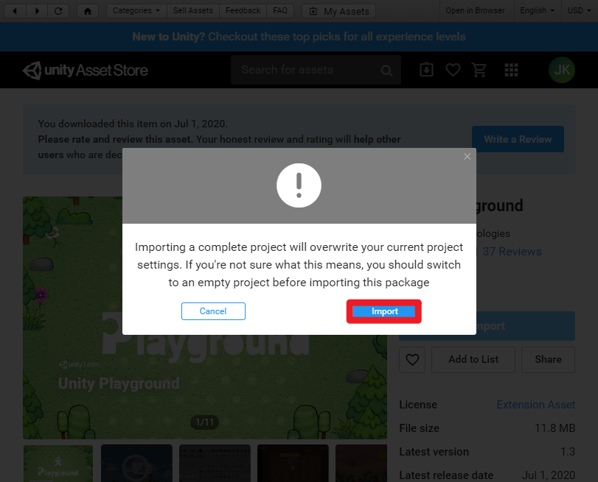
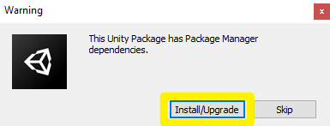
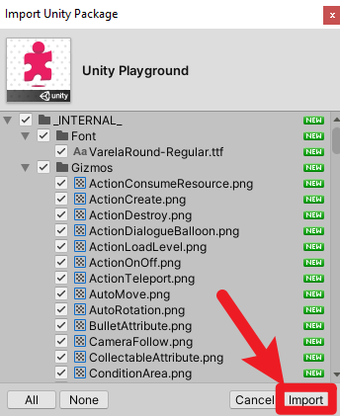

Opening Up A Scene
- In the Project window, we can navigate to the ‘Assets/Examples/Adventure’ folder.
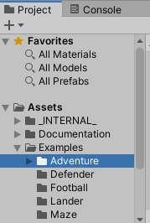
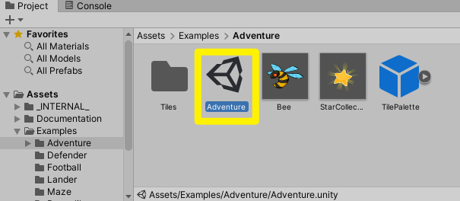
- When we double-click on it, the game will appear in the Scene view. You can use this view to select and position environments, the player, the camera, enemies, and all other GameObjects.
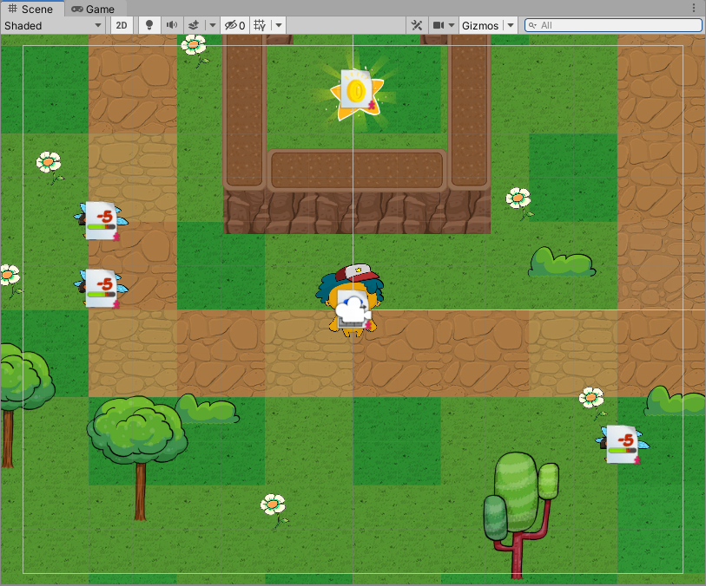
- The Game view allows you to see what the player actually sees when they are playing your game.
- To play the game, press Play button and use W,A,S,D to move around.

Challenge: Play all the sample games in the Examples folder!

